Existing id fetching problem

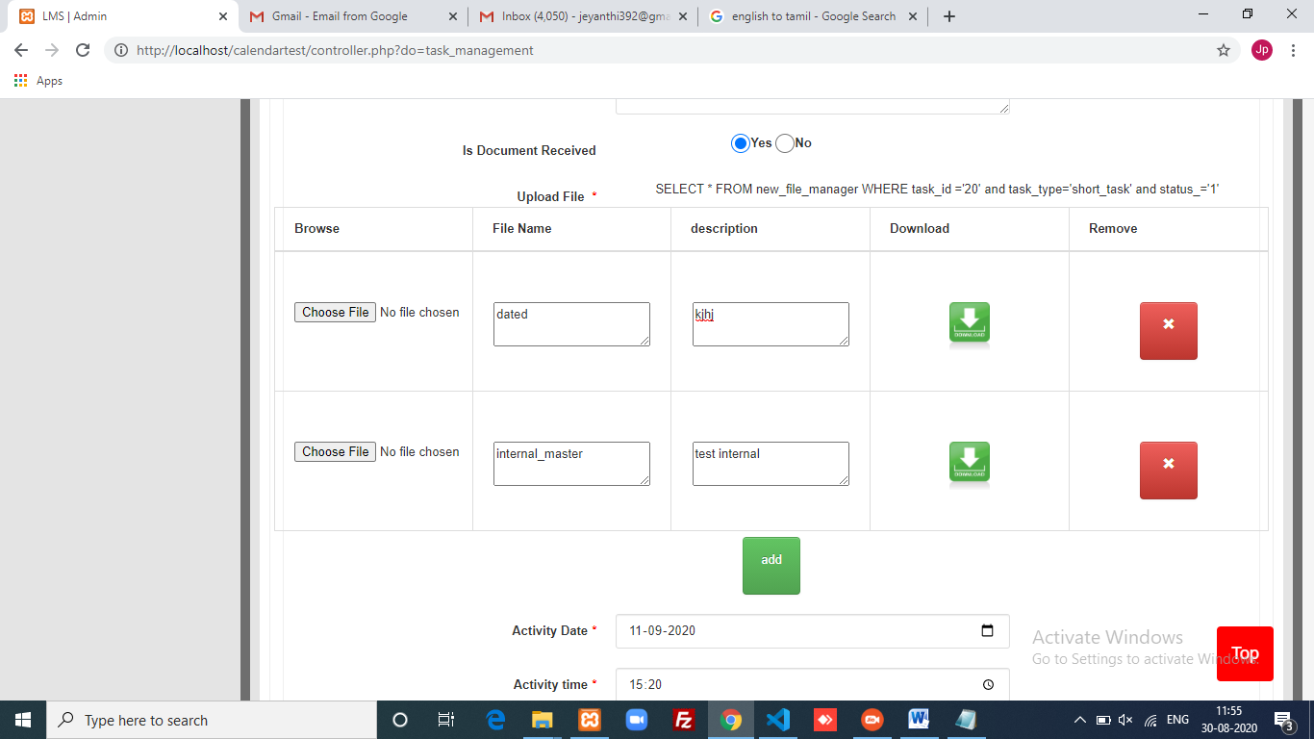
These files are exisiting files.it showed correctly.

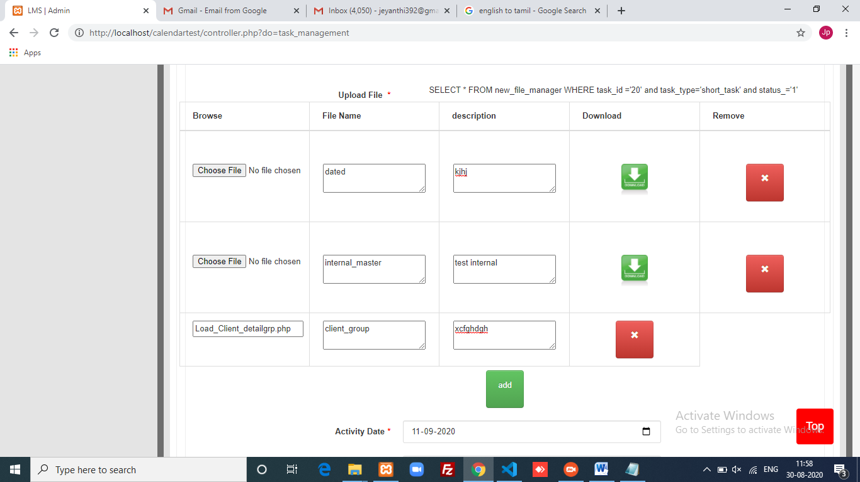
Then I add another new file

Doubt:
In update I want these 3 files details, but I get only newly inserted(3rd file) file in updated page. Please guide me getting these 3 files details in short_update_page.php.

